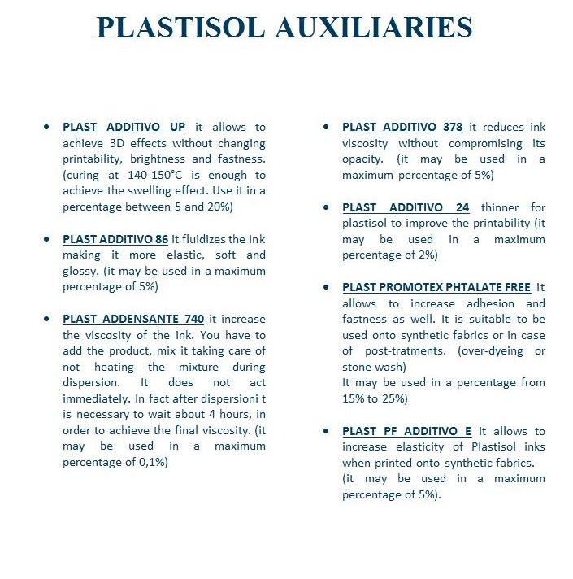

We suggest to add the FIBER BOND to the plastisol with a percentage of 7 - 10%.
The FIBER BOND can be used to increase the washing resistance or to print plastisol inks on special fabrics like nylon.
Please be careful because once you add it to the ink the pot life is around 6 - 8 hours.

(((( all the different info needed to go onto labels for the appropriate products and description for website)))

